Neighborhood Template

City: Lakeville
Neighborhood/Building: Berres Ridge

What’s a brief history of the town/city/suburb?

Type answer here
- https://www.lakevillemn.gov/DocumentCenter/View/570/Residential-Development-Projects-Report-PDF?bidId=
- Hamburg Ave
- Aronson Park
- Just a few blocks away from downtown (Lakeville)
  - Ball Diamonds
  - Soccer Fields
  - Picnic Areas
  - Walking Paths
- Walking Paths
- Lakeville School District 194
- Originally approved for 7 phases in 2015. However, ended up recently approved for the 8th.
  - The 8th phase was approved for 26 single family residential lots and additionally 3 outlots on 30.34 acres of land
  - Located north of 202nd street and west of Hamburg Ave

- Minimum lot size was 11,000 sq ft for interior lots and 12,500 for corner lots.
- Gross density of 0.86 units per acre. The net density excluding outlots is 2.64 units per acre.
- Berres Ridge will be developed in 9 phases, this is the eighth.

What are the HOA fees in the neighborhood? 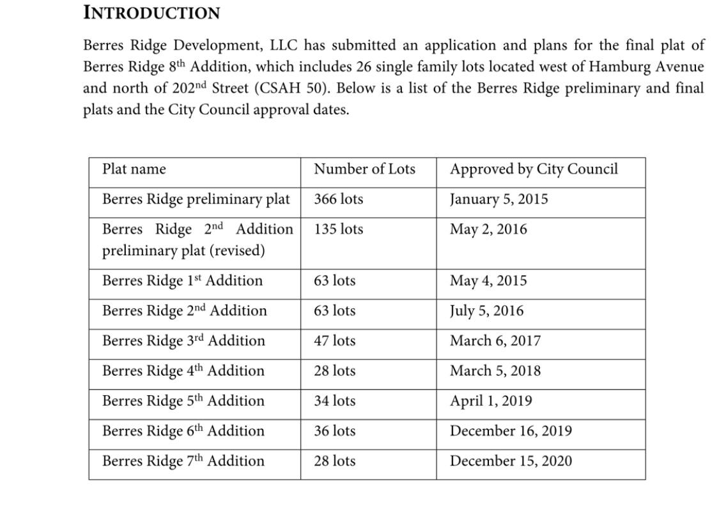

Type answer here

What are the total new construction phases in the neighborhood?

Type answer here
- There are 7 total new construction phases in the Berres Ridge neighborhood.

How many properties are currently built in the neighborhood across all phases?

Type answer here
- 343 lots

How many properties are planned to be built in the neighborhood across all phases?

Type answer here

How many properties are planned to be built across this phase in the neighborhood?

Type answer here

When did the phases in the neighborhood start and when do they plan on being completed?

Type answer here

When did this phase start and when does it plan on being completed?

Type answer here

What are the commute times to the highway and the city / what highways are nearby?

Type answer here

What schools are nearby and do they have any notable accomplishment?

Type answer here

Who is the developer/home builder and what is their history?

Type answer here
- Pietsch Builders
- Sharper Homes
  - https://www.sharperhomes.com/floorplans/
- Hanson Builders
  - https://www.hansonbuilders.com/find-a-home/neighborhoods/arbor-ridge/?gclid=EAIaIQobChMI5MGlrty49wIVG3xvBB24zwLqEAMYASAAEgLuevD_BwE
- Brandl Anderson

Are there any customizations that can be made in this neighborhood or are the spec homes the final done?

Type answer here
- Allowed multiple builders to construct homes on the lots

Are there any customizations that can be made in this neighborhood or are there only finished spec homes?

Type answer here

Are there any average yard dimensions for the neighborhood that you can provide?

Type answer here

What are the HOA requirements for this neighborhood?

Type answer here

Does the suburb plan on growing / Does location have a future regarding expanding?

Type answer here

What do the property taxes look like in the area/city?

Type answer here

Are there any industrial happenings occurring in _____?

Type answer here

Are there any notable corporate employers in the area?

Type answer here

How far away are the top notable corporate employers in the area?

Type answer here

Are there any fun things to do in the area?

Type answer here

Are there any volunteer opportunities in the area?

Type answer here

Are there any notable senior living centers in the area?

Type answer here

Are there any notable daycare centers in the area?

Type answer here

Are there any notable emergency service centers available in the area?

Type answer here

Are there any notable leisure/recreational parks or trails nearby that aren’t explicit to neighborhood?

Type answer here

Are there any well-known lakes in the area?

Type answer here

Are there any unique things you want to mention about the community, Alexa?

Type answer here

If these weren’t the 30 ideas at the top of your head, leave a comment with an extra question below or reach out to the ZOLD team / me for any additional information on any neighborhood that wasn’t mentioned.

Before we go, I just wanted to again quickly mention that I’m your Minnesota realtor Alexa and I’d love to help you with any information regarding real estate.

